HYSPLIT
With NOAA's HYSPLIT service, trajectories can be calculated online. You can find instructions on how to do this below:

Instructions
Click on the pictures to enlarge them.

1. Step
The following link will take you to the entry form: https://www.ready.noaa.gov/hypub-bin/trajtype.pl
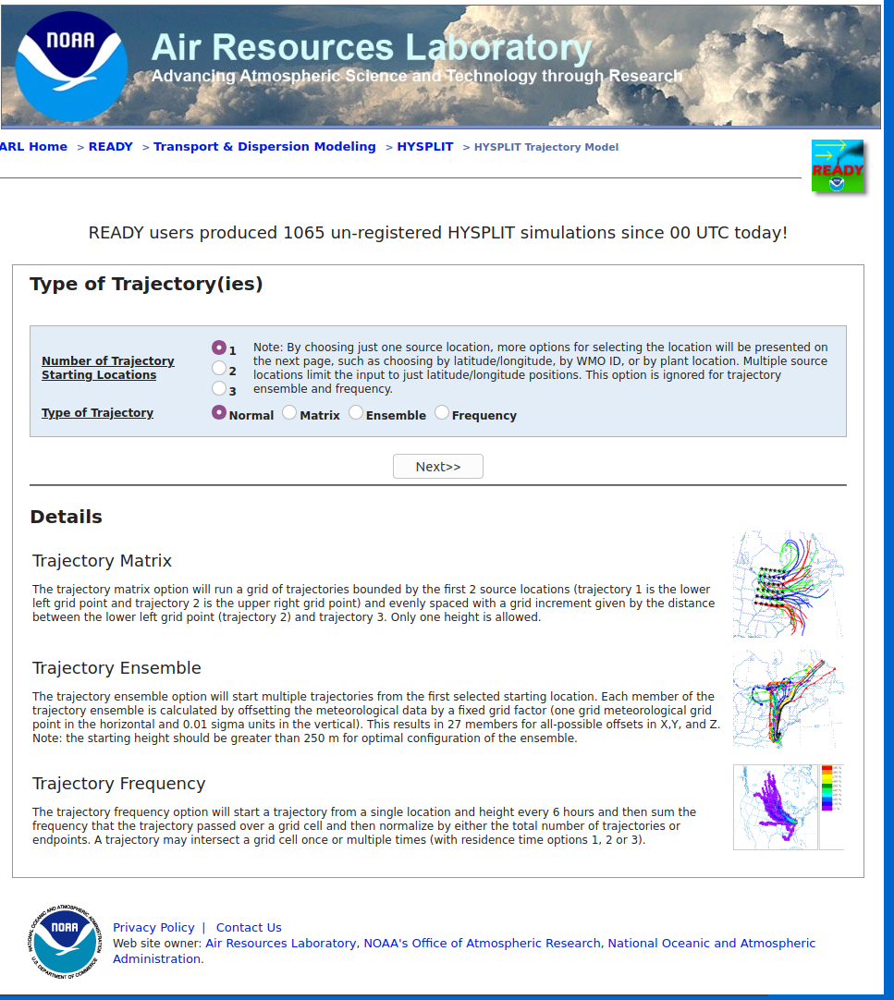NOAA HYSPLIT Entry Form 1st step
Choose 1 Trajectory Starting Location and NORMAL for the Type of Trajectory.

2. Step
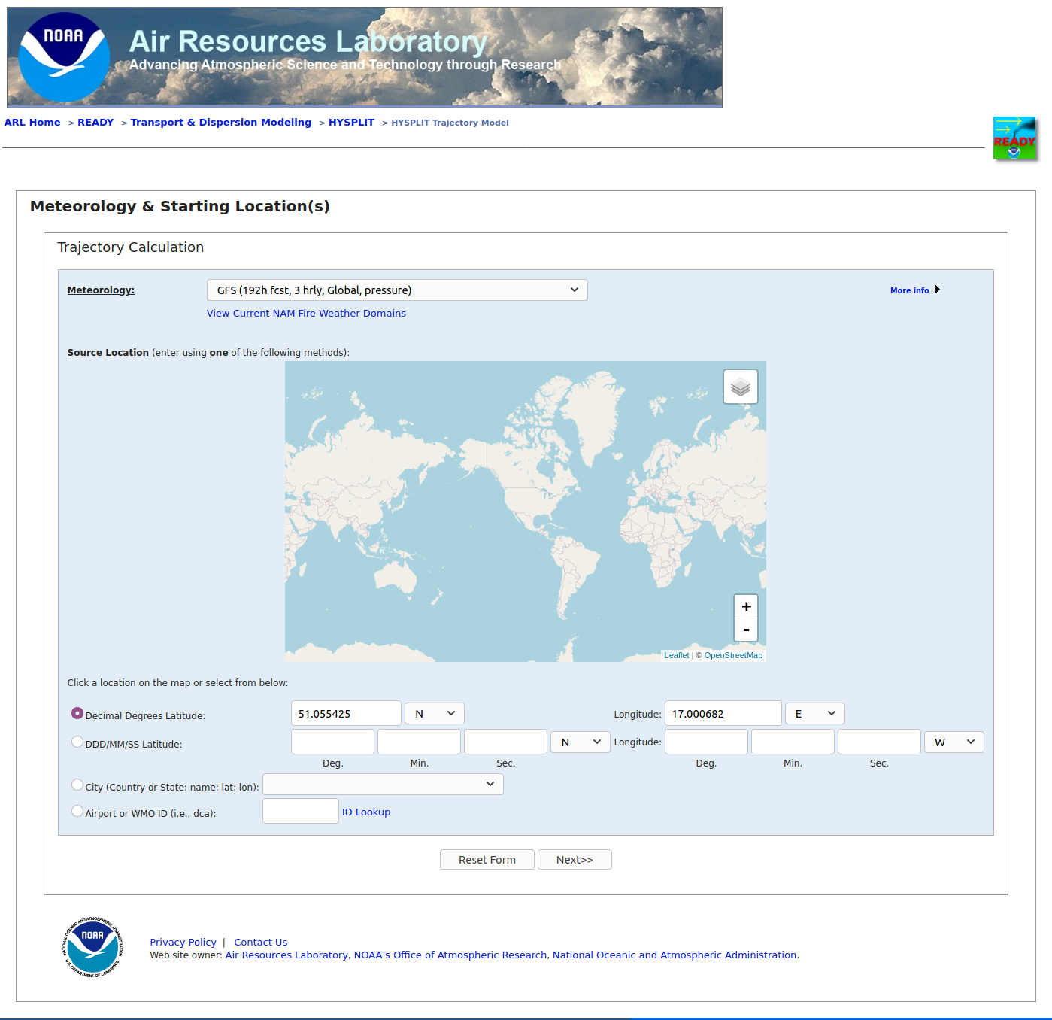HYSPLIT Entry form 2nd step
Here you have to select the weather model and the location where the trajectories start. In the example, we have selected the starting location of the Gordon Bennett Race 2021, Wrocław, Racecourse – Partynice, Poland. (Koordinates: 51.055425 N and 17.000682 E)
Attention: Not all weather models cover the whole world, therefore we choose the GFS model.

3. Step
Select Meteorological Forecast Circle.
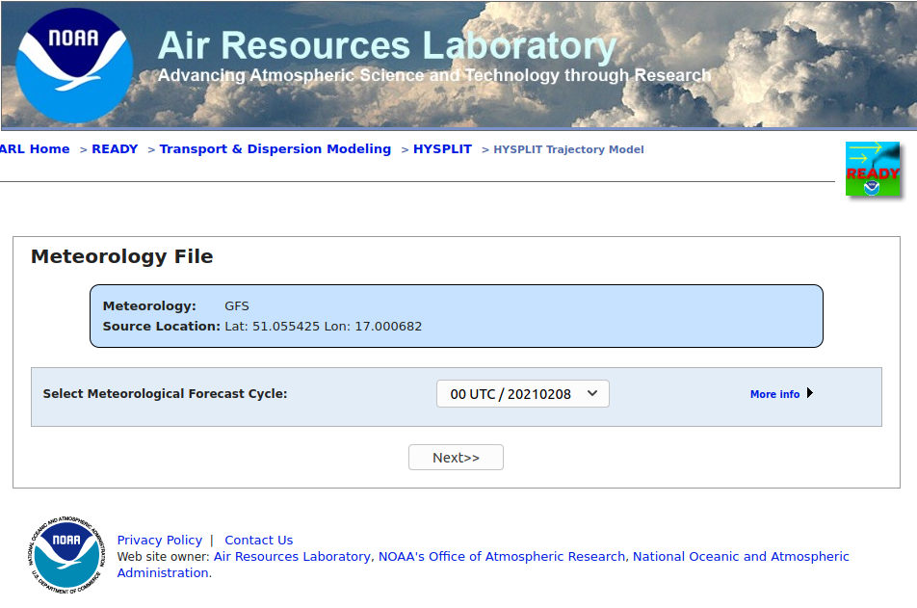HYSPLT 3rd step
Normally, the last calculation run is suggested, and it is a good idea to select this. If you perform several calculations with different runs, you can see whether the forecast is stable or not.

4. Step
Model Run Details
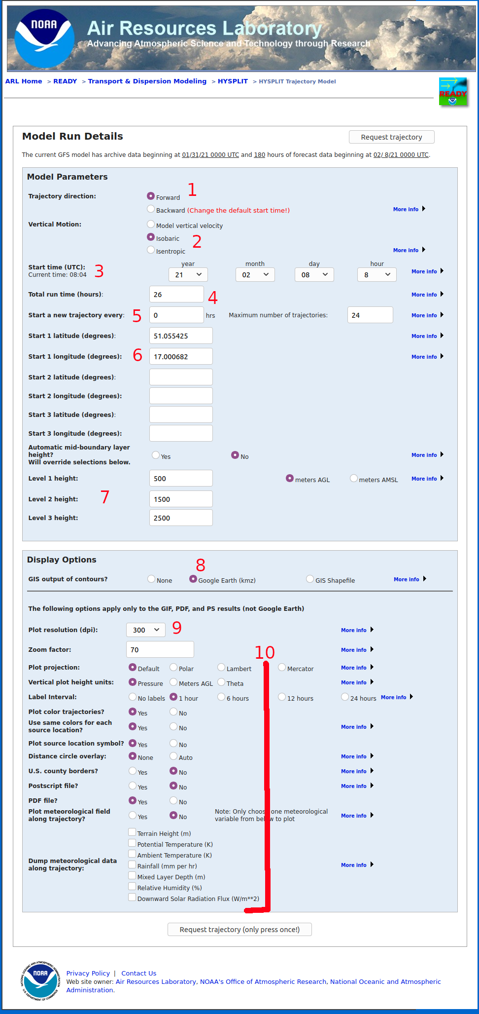Hysplit 4th step
- Trajectory direction: Forward
- Vertical Motion: Isobaric
- Start time (UTC): Your choice
- Your time for this flight altitude
- Here you can specify how often a new trajectory should be started at intervals. First select 0 so that only one is calculated. Later you can experiment with these options.
- Coordinates of the starting point.
- Here you can select up to three heights for which trajectories are calculated.
- Select Google Earth (kmz)
- Here you can choose the resolution of the graphics.
- You can first select the other fields as in the example.
If you click on Request trajectory, you can start the calculation.

5. Results
Now you have to be patient until the calculation and the creation of the graphics are finished.
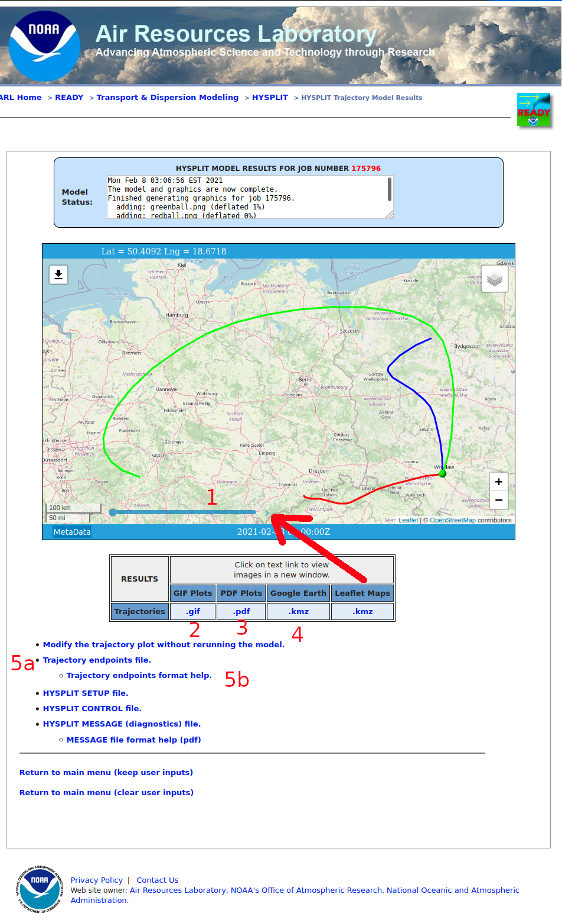HYSPLIT 6th step results.

1 Interactive map
Here you can see when the balloon will be where on the trajectory.

2 GIF
Here you can display the trajectory as a gif.
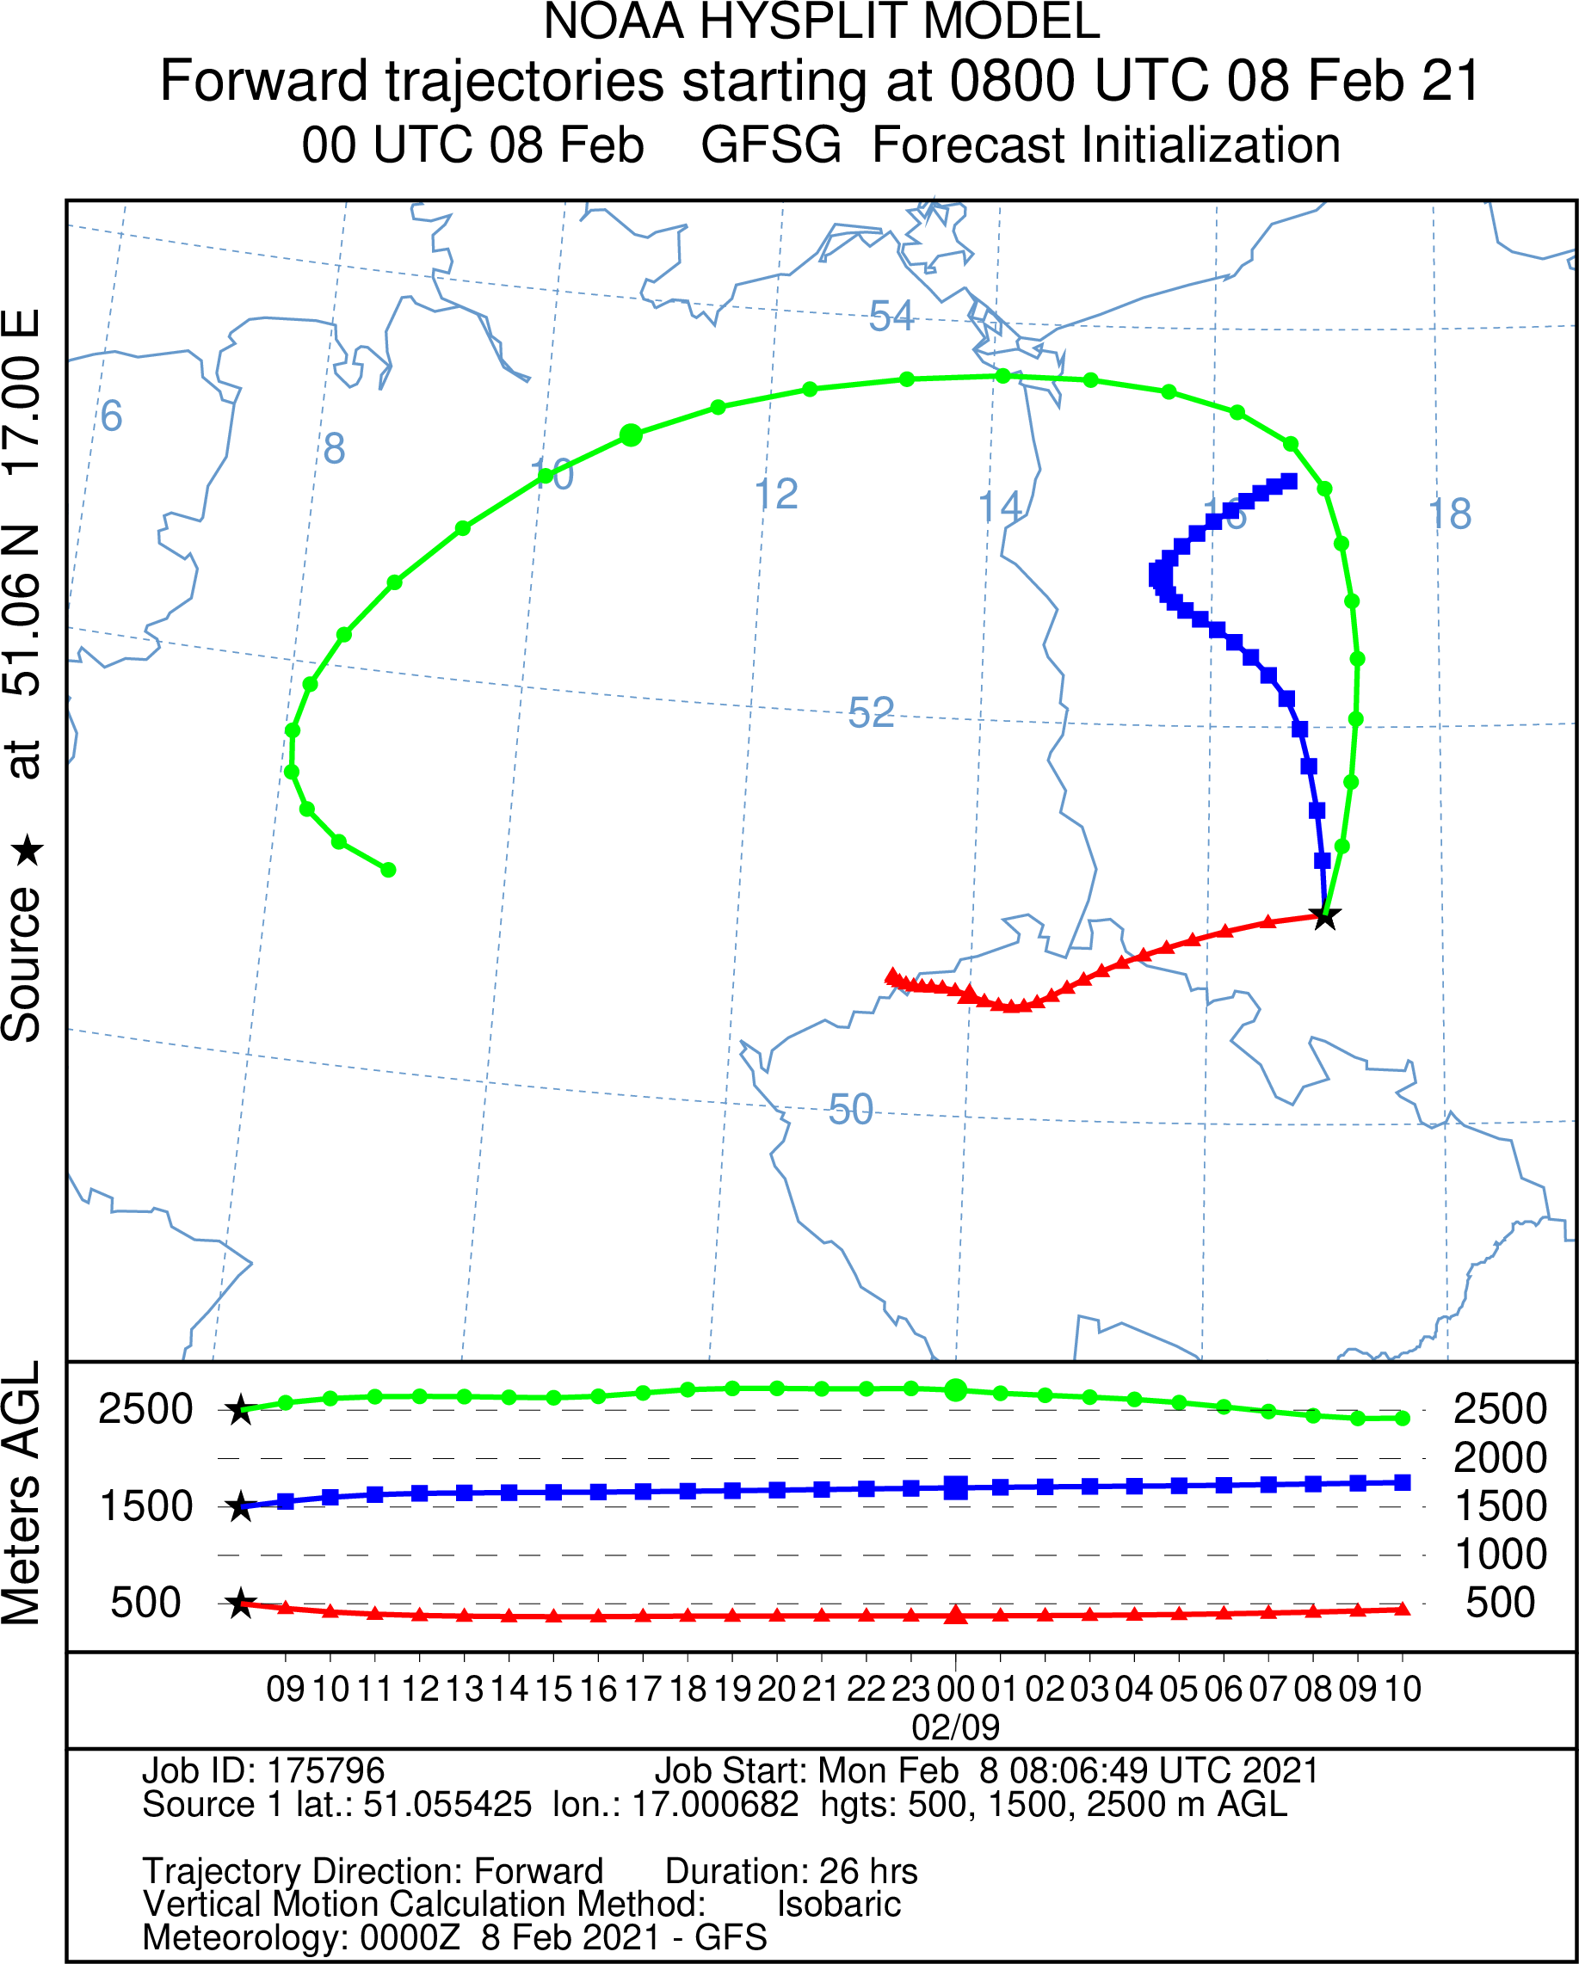Hysplit Trajectory Graphic GIF

3 PDF
hysplit5step2.pdf

4 KMZ Google Earth
hysplit5step3.kmz

5

a. Trajectory endpoints file.
hysplit5step4.txt

b. Trajectory endpoints format help.
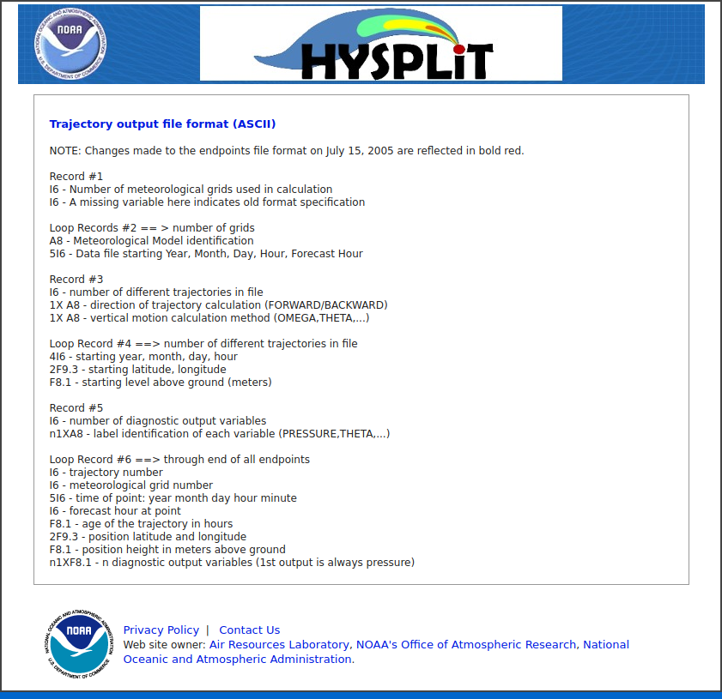Trajectory endpoints format help

This is just one example. Of course, you could experiment with different inputs.
Your comments? Contact Volker Löschhorn.
Tracedump:
newBaseSize: 11pt
newBaseSizeInPt: 11

