Inflation Fan
Gebläse Ventilateur
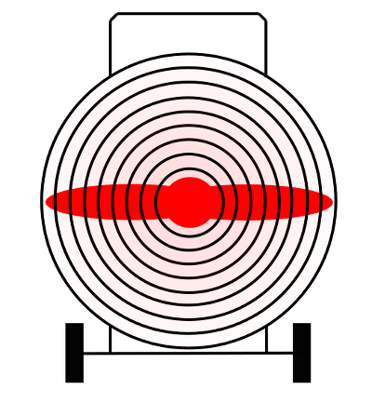Inflation Fan for hot air balloon
Tracedump:
newBaseSize: 11pt
newBaseSizeInPt: 11

